Code 2.1.1 } Write a program to find the roots of a quadratic equation, given its coefficients a,b and c. Use the quadratic formula:

Algorithm :
Step 1: Start
Step 2: Read Inputs
Step 3: Calculate Discriminant
Compute the discriminant:
[D = b^2 - 4ac]
Step 4: Check Conditions of Discriminant
Condition 1: Discriminant > 0 (Two Real and Distinct Roots)
If D > 0, then:
[x_1 = \frac{-b + \sqrt{D}}{2a}]
[x_2 = \frac{-b - \sqrt{D}}{2a}]
Output: Two different real roots.
Condition 2: Discriminant = 0 (Two Real and Equal Roots)
If D = 0, then:
[x = \frac{-b}{2a}]
Output: Two equal real roots.
Condition 3: Discriminant < 0 (Two Complex Roots)
If D < 0, then:
[\text{Real part} = \frac{-b}{2a}]
[\text{Imaginary part} = \frac{\sqrt{-D}}{2a}]
Roots:
[x_1 = \frac{-b}{2a} + i\frac{\sqrt{-D}}{2a}]
[x_2 = \frac{-b}{2a} - i\frac{\sqrt{-D}}{2a}]
Output: Two complex conjugate roots.
Step 5: Display Roots
Print the roots according to the condition.
Step 6: Stop
End the algorithm.

Code :
import math

a, b, c = map(float, input().split())

D = b*b - 4*a*c

if D > 0:
root1 = (-b + math.sqrt(D)) / (2*a)
root2 = (-b - math.sqrt(D)) / (2*a)

print(f"root1 = {root1:.2f}")
print(f"root2 = {root2:.2f}")

elif D == 0:
root = -b / (2*a)
print(f"root1 = root2 = {root:.2f}")

else:
realPart = -b / (2*a)
imaginaryPart = math.sqrt(-D) / (2*a)

print(f"root1 = {realPart:.2f}+{imaginaryPart:.2f}i")
print(f"root2 = {realPart:.2f}-{imaginaryPart:.2f}i")
Flowchart :
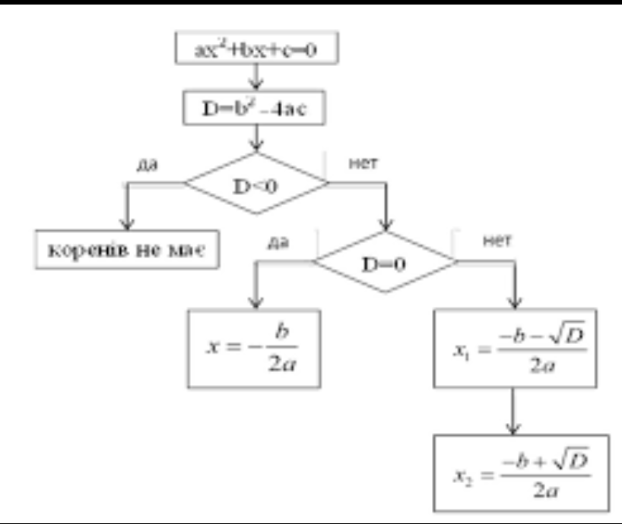

Codetantra :
